Cosmos Quest Battle Calculator

Index

Main Menu 1

Sand Box 2

Quest Solver 5

World Boss Optimizer 9

Settings 10

Main Menu

Once you start the program, you will be taken to the main menu:

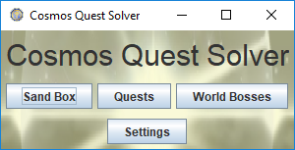

Here, you can select which mode you want to go to. Here is a brief description of each:

Sand Box: Build your own battles, experiment, or just mess around.

Quests: Find possible solutions for quests, daily quests, and dungeon quests.

World Bosses: Find how you can deal the most damage possible to world bosses.

Settings: Change the order in which heroes and monsters are listed.

The rest of this guide shows how to use these features. It is recommended you read this guide front to back, since many concepts and GUIs are shared between modes and they are only explained once.

Sand Box

Let’s start with the first button on the main menu: the sand box. This is where you can test and analyze strategies for individual battles. Clicking on this button will open the following screen:

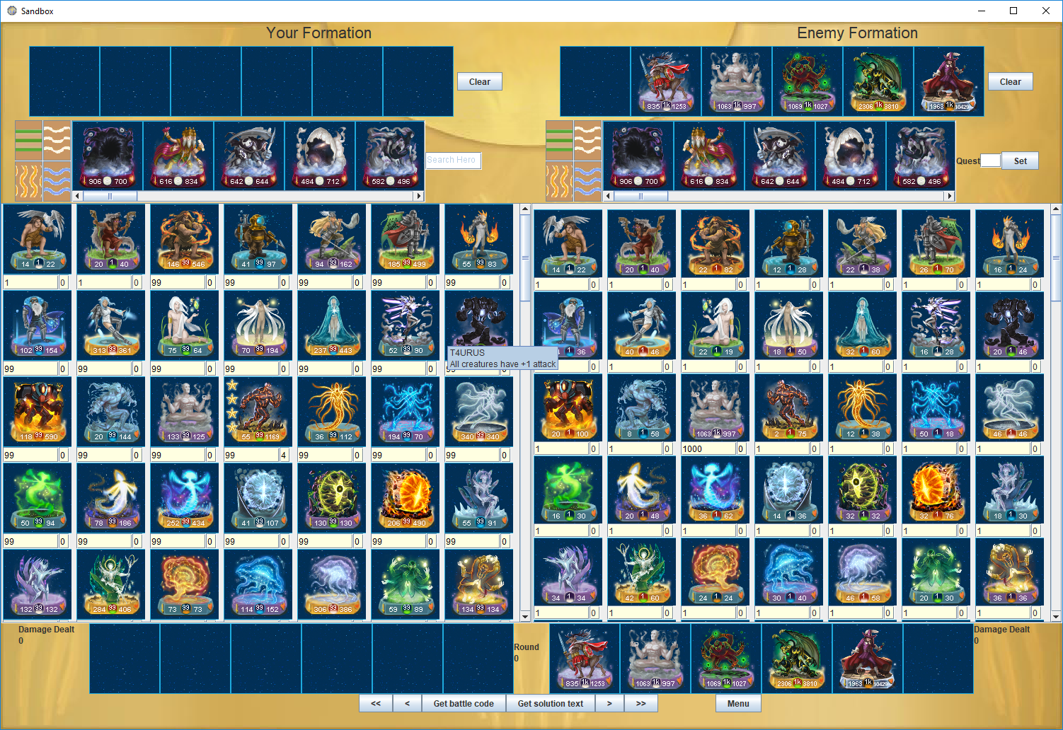

It looks a bit overwhelming at first, so let’s break it down and talk about each part individually.



6

4

5

3

2

1

Firstly, the interface is divided into 3 parts: the left side, where you can build your formation, the right side, where you build the formation you’re fighting, and the bottom side, where you can see the battle played out. Elements 1, 2, and 3 exist for both the left and right sides, and work the same way.

***Component 1: Hero Selector***

Here, you can adjust the levels for each hero using the text box below. Clicking on the picture of the hero will “select” it. You can then place that hero into a slot in Component 3. If a hero is already in Component 3, changing its level or promotion here will automatically change the level in Component 3.

*** Component 2: Monster Selector***

Here, you can select a monster to place in Component 3. Monsters are ordered by tier. You can change elements by clicking on the appropriate button on the left.

*** Component 3: Formation Slots***

Once you have selected a creature from components 1 or 2, you can click on one of the slots in this element to place it. The order in which the creatures fight each other mirrors how they fight in the game’s battle replay. For your formation (left) the creature on the right fights first, and for the enemy formation (right), the creature on the left fights first. Positions of empty spaces are not important unless the other formation has a skill that relies on randomness. You can press the escape key to delete a unit in your cursor. If your mouse has a middle button, you can press it to copy units, or scroll to switch between tiers of monsters or level heroes.

***Component 4: Quest Selector***

Here, you can select which quest you want to face. Just type in the number of the quest and press the “Set” button and the right side’s Component 3 to the monsters faced in that quest.

***Component 5: Replay visualization***

Here, you can see how the battle plays out. Upon updating Component 3, this component will automatically update and go to the last turn so you can see which side won. You can view the battle using the buttons on the bottom.

**<<**: go to first turn

**<**: go back one turn

**>**: go forward one turn

**>>**: go to last turn

**Get battle code**: copies some text onto your clipboard. This text looks meaningless, but you can use it to show the animated replay in-game. From the Miracles tab, choose Tournaments -> Last Tournament Results -> Import Battle and paste the text there.

**Get solution text**: Copies a human readable version of the battle at its start. Good for sharing solutions.

**Menu**: go back to main menu

***Component 6: Hero Filter***

Cosmos Quest has a lot of heroes, so it may be difficult to find the hero you’re looking for. If you know the name or partial name of a hero, type it in here and all the heroes that don’t have that text in their name (Capitals don’t matter) will be temporarily hidden.

Quest Solver

This is where the app starts getting really useful. Sometimes, it can be difficult to be sure if you cannot complete a quest given your current heroes and followers. As a result, you may spend quite a lot of time trying different strategies, which might be in vain. This program helps you find solutions to tricky quests much easier.

Click on the “Quests” button in the main menu. You will then see an interface similar to the Sandbox

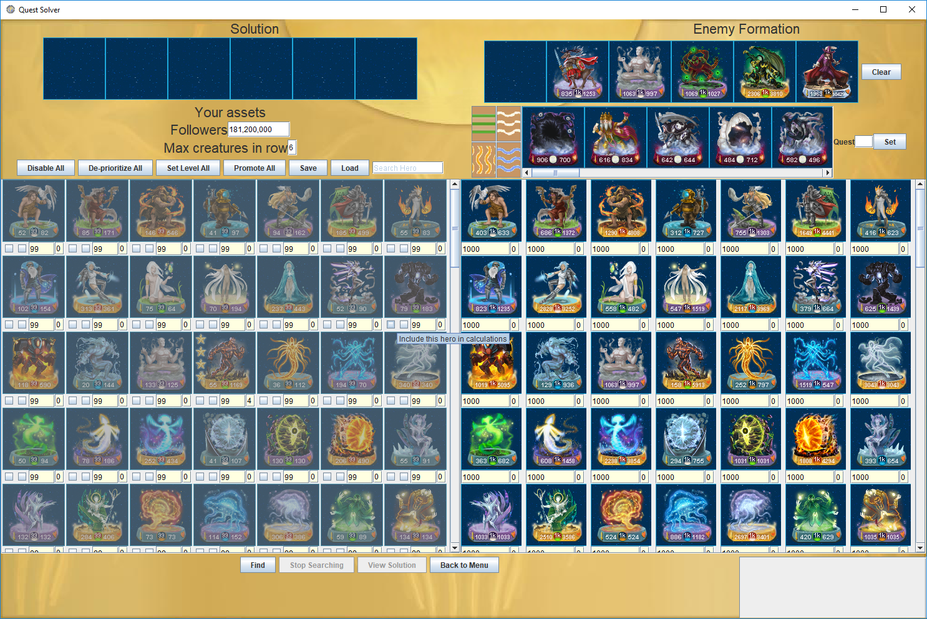

As before, let’s break this interface down into parts



5

6

4

3

2

1

***Component 1: Quest Builder***

This component is the same as the right side of the Sandbox interface. Here, you can construct the formation you want the program to find a solution to.

***Component 2: Solution Display***

If a solution is found, it will be displayed here (first creature on the right). Unlike the left side of the Sandbox interface, this display is not editable.

***Component 3: Followers and Max Creatures***

Instead of selecting which monsters to use, just put in the maximum followers the program can use in the top text box. The bottom text box limits the number of creatures that can be used in a solution—useful for solving quest objectives 2 and 3 or promoting a hero to level 2.

***Component 4: Hero Selector***

Like the hero selector in the Sand box interface, you can adjust the level of your heroes here. You can’t select them, however. It’s the program’s job to find out which heroes to use!

Unfortunately, there are too many possibilities for the program to try, so you’re going to have to help it out a little.

Always include



Promotion

Level

Include

Each hero now has two buttons to the left of its level text field. Clicking the one on the left will remove the gray shading over the hero’s picture, letting the program know that it should consider this hero as part of a possible solution to the quest. The program will not consider grayed-out heroes when searching for a solution. This speeds up the search process, however.

As a general rule, you should only include your strongest heroes in searches, and maybe some support heroes as well if you think they will give your stronger heroes the edge they need.

The right button, when pressed, prioritizes a hero, forcing the program to only try formations that have this hero in it. This is good for when you know that a specific hero is required for a solution or if you tried finding a solution for a quest, failed, and then leveled up a hero and want to know if that extra level would make the difference. Prioritized heroes will speed up the calculations, as there will be fewer fights to simulate.

A hero cannot be both not included and prioritized, so if pressing one button makes this the case, the other button will automatically be pressed. If there are more prioritized heroes than creatures the program is allowed to use (bottom of Component 2) the program will refuse to run.

***Component 5: Quick-Leveling Buttons***

Above the heroes are 6 buttons to speed up the process of leveling your heroes.

**Disable All**: grays out all heroes

**De-Prioritize All**: de-prioritizes all heroes

**Set Level All**: opens a pop-up menu asking for a number, sets all hero levels to that number.

**Promote All**: opens a pop-up menu asking for a number, sets all hero promotions to that number.

**Save**: saves the current state of all heroes. This state will be loaded up automatically when this window opens again.

**Load**: sets all hero states to the state that you saved.

Note: The world boss interface also uses load and save. Hero levels are shared, but each interface has its own data for which heroes are selected and prioritized.

***Component 6: Search Controller***

Here, you can control when the searcher starts and stops, and see information on its progress Let’s look at the buttons first.

**Find**: When your parameters from above are set up, hit this button to start the search.

**Stop Searching**: If the search is taking too long, and you are reasonably sure that there is no solution, hit this button to stop the search.

**View Solution**: If a solution is found, this button will become active. Click on it for a pop-up showing the battle replay.

**Back to Menu**: Takes you back to the main menu.

When you start the search, a list of heroes and monsters will appear in the white box on the lower right. This shows the order in which the program tests possible solutions. It will try all permutations with the first few creatures on the list before including the next. Prioritized heroes are not included here because they are always part of each attempt. The order of the creatures on this list is such that the stronger heroes are listed first. Heroes are given priority over monsters, and special abilities are taken into account when calculating strength.

Also when you start the search, some text will appear on the bottom of the screen. This tells you the most recent creature the solver is considering when finding a solution. The order of these creatures is the same as those on the list mentioned above. This also tells you that all possible permutations involving any of the creatures higher on the list have already been tried.

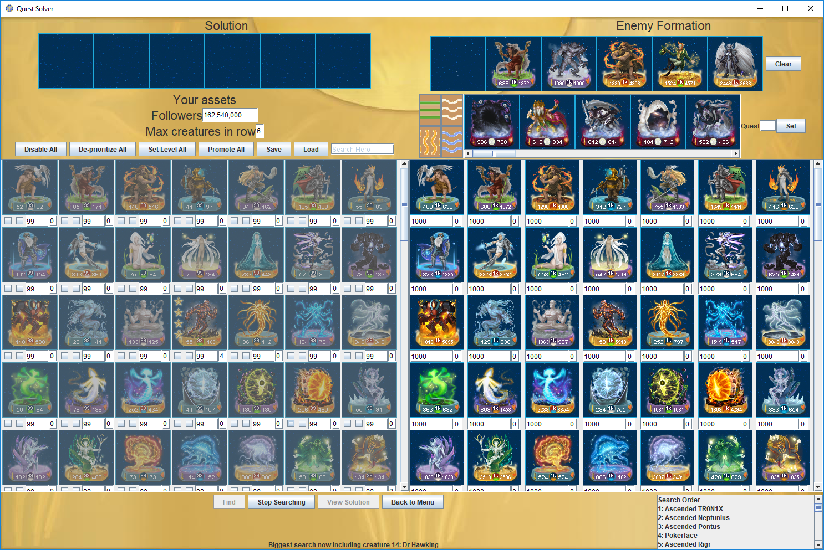

World Boss Optimizer

The next feature determines the maximum damage you can deal to a world boss in a single attack. Clicking on the “World Bosses” button in the main menu will take you here:

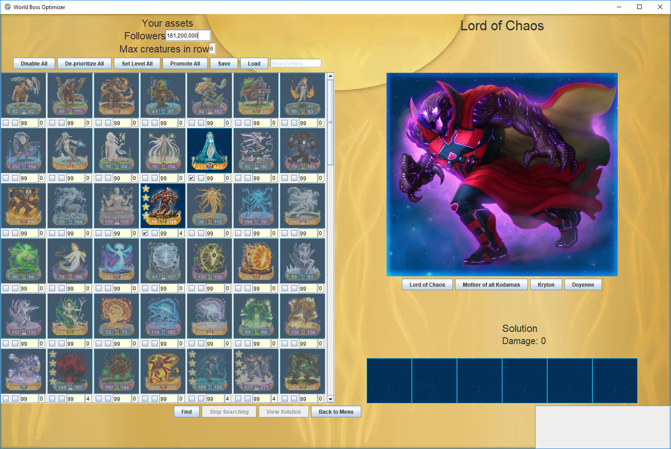

Best solution shown here

Select boss here

This layout is very similar to the quest solver, and it works in almost exactly the same way. As before, you can choose what heroes you want to be included and prioritized in your search, as well as available followers and how many creatures to use (normally 6, but sometimes less are needed for Lord of Chaos without any heroes). You can select which boss to fight and view solutions on the right.

Also as before, click on the “Find” button to start searching for an optimal solution. The program will try all possible permutations of creatures starting with the strongest (element advantage is also taken into account when determining creature strength). The solution display panel will update whenever a new record for damage has been found. If monsters were used in the solution, it will also state how many were used. Again, if you do not think a better solution exists that includes monsters lower on the list in the bottom right, you can stop the search with the “Stop Searching” button.

Settings

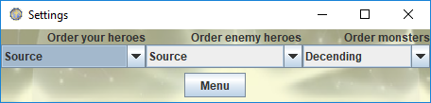

Here you can select the order in which heroes and monsters appear, among several different settings. These settings are saved as soon as you select an option. Try to find the order that you find most intuitive to you.